**Activity 2: Creating an Ntier Architecture using CF Template**

* Lets start the template, to create the following  
  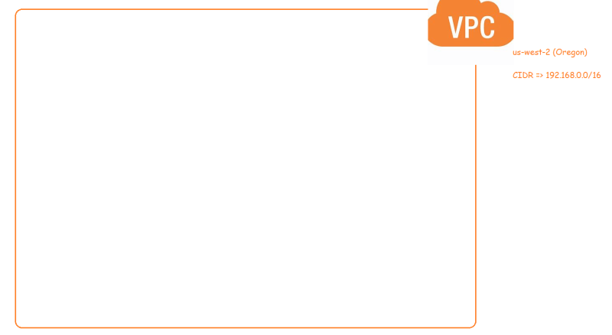
* For manual steps refer classroom video
* inputs =>
* vpc cidr range => 192.168.0.0/16
* <https://docs.aws.amazon.com/AWSCloudFormation/latest/UserGuide/template-anatomy.html> for cloud formation template anatomy
* <https://docs.aws.amazon.com/AWSCloudFormation/latest/UserGuide/aws-resource-ec2-vpc.html> for cloud formation vpc
* <https://github.com/asquarezone/awsadministration/commit/df906adb792f577eb98d9caec61e7c7db3678e8f> for the changeset for vpc
* Lets create the stack  
  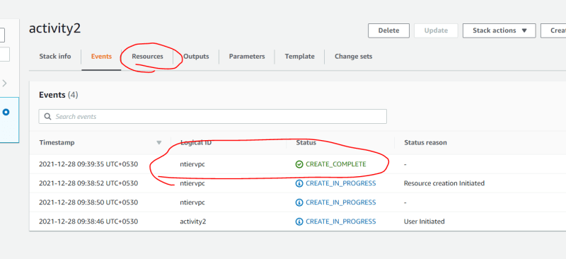  
  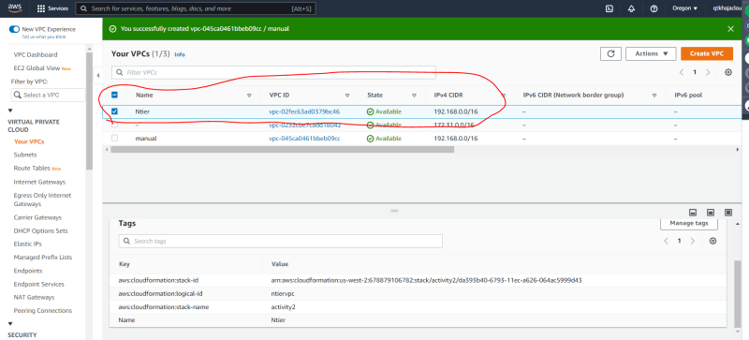
* Generally we write templates so that we can reuse.
* To make reusability more effecient, we should paramterize.
* In Cloudformation, we can add parameters <https://docs.aws.amazon.com/AWSCloudFormation/latest/UserGuide/parameters-section-structure.html>
* The syntax of paramer is as follows

"Parameters" : {

"ParameterLogicalID" : {

"Type" : "DataType",

"ParameterProperty" : "value"

}

}

* To use the parameter value syntax is { "ref": "<parameter-name>" }
* In the documentation when we see the Parameter with Update Requires
* Replacement: When we change this value the resource will be recreated
* No interruption: When we change this value the existing resource will be updated withour recreation
* <https://github.com/asquarezone/awsadministration/commit/b56a442d1e7515928901eecf1f83197afd61b660> for the changes done, Now lets update the cf stack  
  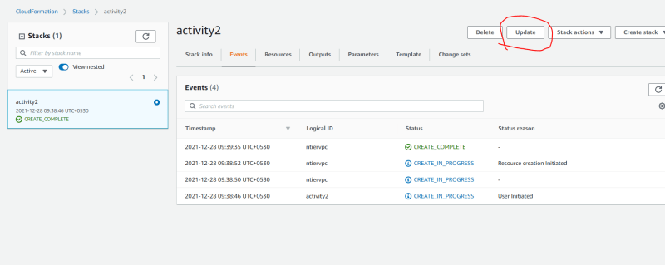  
  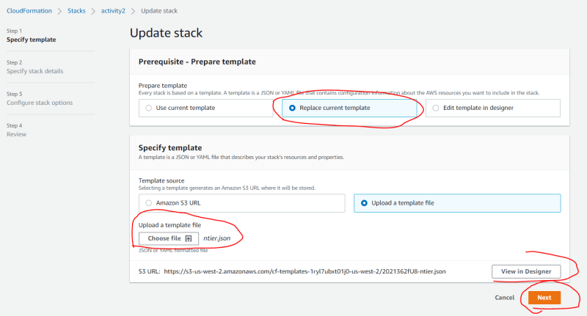  
  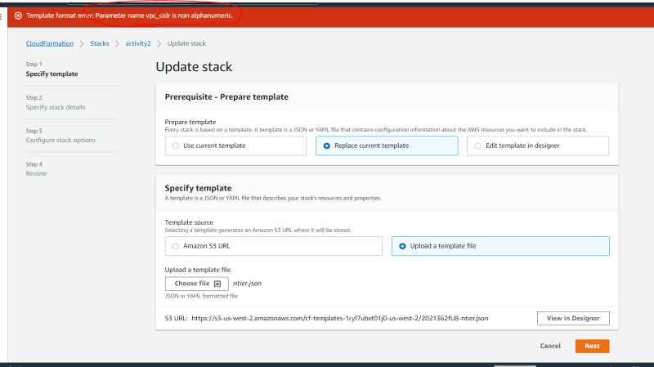
* There are naming conventions for giving parameter names
* Now lets update the template with fix
* <https://github.com/asquarezone/awsadministration/commit/76d42df249666d6c02fd0bb56a22c129b9e2fce4>   
  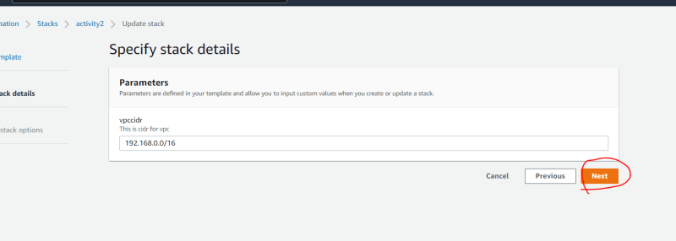
* Now lets Enable DNS Hostnames for VPC. <https://github.com/asquarezone/awsadministration/commit/db8cac3cd28103c3bc65ed487eb0010680348e19>   
  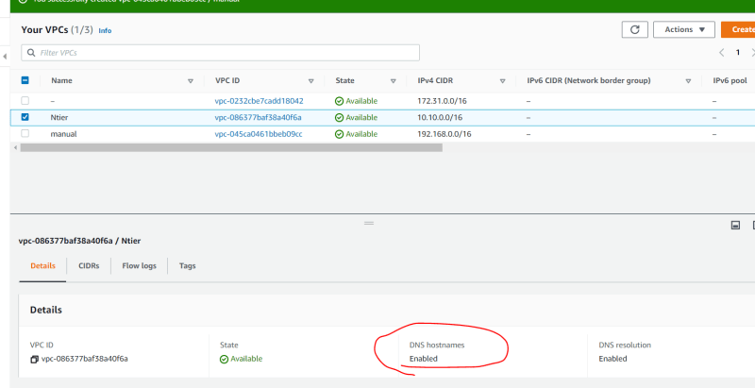
* For YAML Lovers refer below

---

AWSTemplateFormatVersion: '2010-09-09'

Description: This is template for activity 2

Parameters:

vpccidr:

Description: This is cidr for vpc

Type: String

Default: 192.168.0.0/16

Resources:

ntiervpc:

Type: AWS::EC2::VPC

Properties:

CidrBlock:

Ref: vpccidr

EnableDnsHostnames: true

Tags:

- Key: Name

Value: Ntier